Description: Description: G:\2017-18\SCHOOL ALL OVER\BODHI LOGO.jpg**VELAMMAL BODHI CAMPUS**

**Grade:** X – Batch II **GRAND TEST – I (2023-24) Sub:** Social Science

**Date :30.11.2023 Marks:** 80

1. This question paper has six sections: Section A, Section B, Section C, Section D, Section E and section F. There are 37 questions in the question paper. All Questions are compulsory
2. Section A contains 20 questions of one mark each (Q.1 to Q.20),
3. Section B contains 4 questions of two marks each (Q.21 to Q.24),
4. Section C contains 5 questions of three marks each (Q.25 to Q 29)
5. Section D contains 4 questions of five marks each (Q. 30 to Q 33)
6. Section E contains three case based (Subjective) of four marks (Q.34 to Q.36)
7. Section F contains Map Work Based Questions five question of 1 Mark each with two parts, part A from History (2 marks) and part B from Geography (3 marks) as Q. 37 A and B.
8. There is no overall choice in the question paper. However, and internal choice has been provided in few questions. Only one of the choices in each questions have to be attempted. In addition to this separate instructions are given with each section and question wherever necessary.

**Section – A Multiple Choice Questions (20×1=20)**

**1. Consider the following statements regarding Dandi March organised by Mahatma Gandhi and identify the incorrect one from the following.**

(a) Mahatma Gandhi started the Dandi March from Sabarmati Ashram

(b) Dandi March is also known as salt march

(c) Dandi March was started on 12 March 1930

(d) Mahatma Gandhi accompanied 72 of his trusted members.

**2. The three major cropping seasons of India are:**(a) Aus, Aman and Boro (b) Rabi, Kharif and Zaid  
(c) Baisakh, Paus and Chait (d) None of the above

**3. Read the data given in the following table and answer the given question.**

|  |  |  |  |
| --- | --- | --- | --- |
| **Monthly income of citizens** | **Country** | | |
|  | **Country A** | **Country B** | **Country C** |
| **Group I** | 9000 | 5000 | 2000 |
| **Group II** | 10000 | 4000 | 1600 |
| **Group III** | 8000 | 6800 | 3500 |
| **Group IV** | 1100 | 5050 | 3000 |
| **Group V** | 12500 | 29650 | 10000 |
| **Average Income** | **?** | **?** | **?** |

**Which country has more equitable distribution of income?**

(a) Country C (b) Country A (c) Country B (d) Both ‘Country A’ and ‘Country B’

**4. The Indian Wildlife Protection Act was implemented in:**(a) 1972 (b) 1971 (c) 2010 (d) 1982

**5. Division of power between higher and lower level of government is known as**

a) vertical division of power b) horizontal distribution of power

c) union division of power d) community division of power

**6.** **Assertion** : Hindi is identified as the official language of India.

**Reason** : It helped in creating supremacy of Hindi speaking people over others.

(a) Both A and R are true and R is the correct explanation of A.

(b) Both A and R are true but R is not the correct explanation of A.

(c) A is true but R is false.

(d) Both A and R are false.

**7.Democracy is preferred over dictatorship everywhere except**

(a) Nepal (b) Pakistan (c) India (d) Bangladesh

**8.** **Assertion (A):**Members can take small loans from the group itself to meet their needs through Self-Help Groups.  
**Reason (R):**SHGs are the building blocks of organization of the rural poor.  
(a) Both A and R are true and R is the correct explanation of A  
(b) Both A and R are true, but R is not the correct explanation of A  
(c) A is true, but R is false  
(d) A is false, but R is true

**9. Laws concerning family matters such as marriage, divorce, adoption etc. are known as:**

(a) Family laws (b) Constitutional Laws (c) Criminal Laws (d) Civil Laws

**10. Consider these statements about the Image given below**

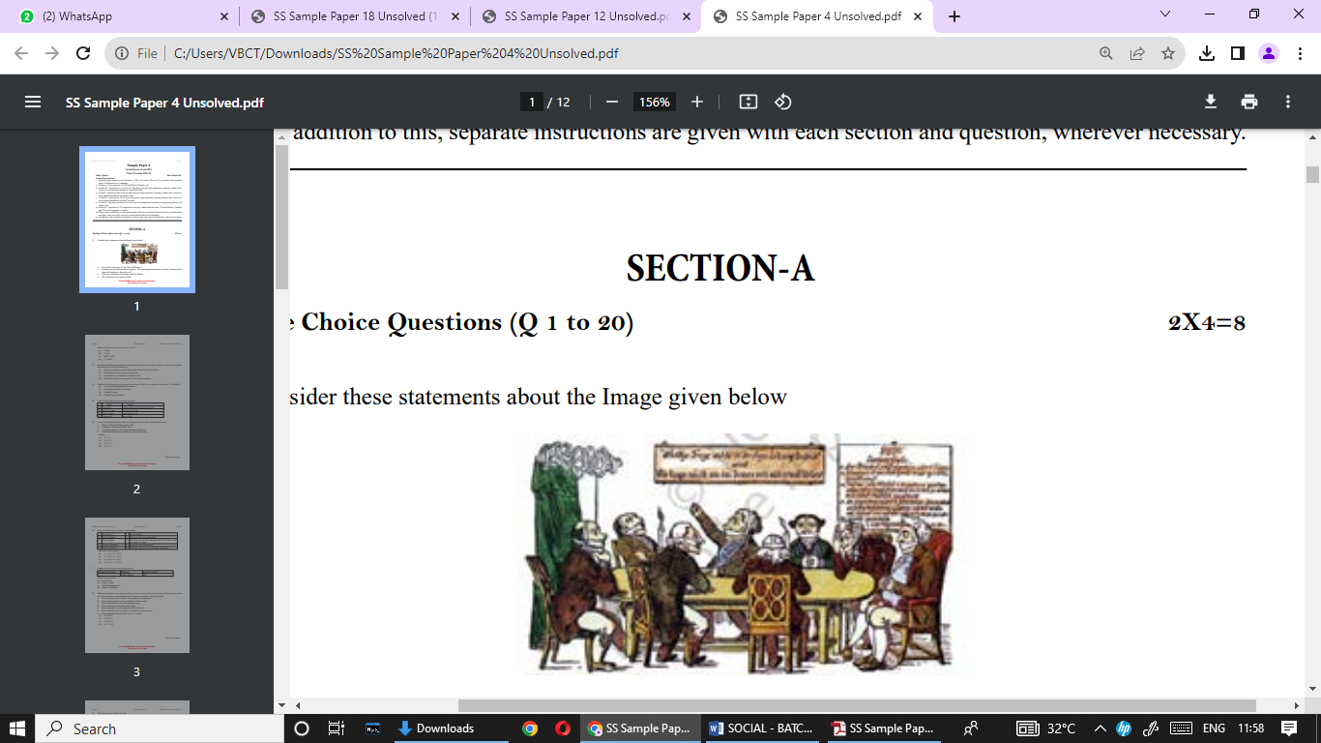1. Title of this caricature is “The Club of Thinkers”.

2. The plaque on the left bears the inscription:

‘The most important question of today’s meeting:

How long will thinking be allowed to us?”

3. This was a caricature of meeting called by liberals.

4. This caricature was created in 1820.

**Which of the above statement(s) is/are correct?**

(a) 1 only (b) 2 only (c) Both 1 and 2 (d) 1, 2 and 4

**11. Which has played a big role in spreading globalisation?**

a) Information Technology b) Transport c) Both (a) and (b) d) less competition

**12.** **Choose the correction option to complete the statement.**

**If a government provides its citizens a right and means to examine the process of decision, it is……………………...**

a) An accountable government. b) A responsible government.

c) A transparent government. d) A stable government

**13. Arrange the following events in correct chronological order.**

**(**1) Rowlatt satyagraha (2) Khilafat movement

(3) Jalianwala Bagh massacre (4) Kheda satyagraha

a)4,1,3,2 b)2,1,3,4 c)1,2,3,4 d)4,3,2,1

**14.** **NREGA (National Rural Employment Guarantee Act of 2005) has guaranteed ………. days of employment in a year in many districts of India. What are the correct number of days?**

(a) 200 days (b) 100 days (c) 30 days (d) 60 days

**15. Which one of the following is the oldest Japanese book?**

**(a) Sutta Pitaka (b) Diamond Sutra (c) Mahavamsa (d) Dipavamsa**

**16. In which of the following States is black soil found?**(a) Jammu Kashmir (b) Gujarat (c) Rajasthan (d) Jharkhand

**17.** **Which of the following comes under the tertiary sector?**

a) transport b) communication c) both (a) & (b) d) none of the above

**18.** **Which one of the following Indian industries has been hit hard by globalization?**

(a) Information Technology (IT) (b) Toy making (c) Jute (d) Cement

**19.**  **______ region has the highest representation of women in their national parliaments.**

a) Pacific b) Americas c) Middle-east d) Nordic countries

**20.** **If BMI is less than 18.5 then the person would be considered:**

(a) over weight (b) long height (c) under nourished (d) short height

**Section-B Answer the following questions in very short (4×2=8)**

21. Explain any three consequences of the majoritarian policies adopted by the Sri Lankan

government.

22. How did the discovery of America in the 16th century transform trade and lives

everywhere? Give one example.

OR

The new crops could make the difference between life and death”. Explain the above

statement in context of Irish Potato Famine.

23. Write the main characteristics of intensive subsistence farming.

24. What is Human Development Index? Give examples.

**Section – C Answer the following questions in brief (5×3=15)**

25. Give any three reasons favouring shift from hand printing to mechanical printing in

China?

26. A) Explain any three ways to solve the problem of underemployment.

OR

B) What is meant by Gross Domestic Product (GDP)? How is GDP measured in India?

27. Why are some pulses known as leguminous crop? Why are they grown in rotation with

other crops?  
28. Explain the accommodation principles of Belgium

29. What is a trade barrier? Why did the Indian Government put up trade barriers after

Independence? Explain.

**Section – D Answer the following questions in detail (4×5=20)**

30. **A**. The first clear expression of nationalism came with the French Revolution in 1789. Elucidate.

**Or**

**B**. Describe the explosive conditions prevailed in Balkans after 1871 in Europe.

31. **A**. Highlight the importance of petroleum. Explain the occurrence of petroleum in India.

**Or**

**B**. Why is conservation of mineral resources essential? Explain any three methods to conserve them.

32. **A**. Analyse the role of a multiparty system in a democratic country like India.

**Or**

**B**. How political parties can be reformed and give three suggestions.

33. **A**. How can the formal sector loans be made beneficial for poor farmers and workers?

Suggest any five measures

**Or**

**B.** Explain the significance of The Reserve Bank of India in the Indian economy.

**Section-E Case Based Questions (3x4=12)**

**34. Read the source given below and answer the questions:**

**Mahatma Gandhi’s thoughts on Satyagraha**

‘It is said of “passive resistance” that it is the weapon of the weak, but the power which is the subject of this article can be used only by the strong. This power is not passive resistance; indeed it calls for intense activity. The movement in South Africa was not passive but active …’

‘Satyagraha is not physical force. A satyagrahi does not inflict pain on the adversary; he does not seek his destruction … In the use of satyagraha, there is no ill-will whatever.’

‘Satyagraha is pure soul-force. Truth is the very substance of the soul. That is why this force is called satyagraha. The soul is informed with knowledge. In it burns the flame of love… Non-violence is the supreme dharma …’

‘It is certain that India cannot rival Britain or Europe in force of arms. The British worship the war-god and they can all of them become, as they are becoming, bearers of arms. The hundreds of millions in India can never carry arms. They have made the religion of non-violence their own

**QUESTIONS:**

34.1. What type of movement Gandhiji organised in South Africa? [1 mark]

34.2. Why is satyagraha considered as pure soul-force? [1 mark]

34.3 How has Gandhiji described passive resistance? [1 mark]

34.4 What did the idea of satyagraha mean? [1 mark]

**35. Read the passage below and answer the questions that follow:**

**RAINWATER HARVESTING**

Many thought that given the disadvantages and rising resistance against the multi-purpose projects, water harvesting system was a viable alternative, both socio-economically and environmentally. In ancient India, along with the sophisticated hydraulic structures, there existed an extraordinary tradition of water harvesting system. People had in-depth knowledge of rainfall regimes and soil types and developed wide ranging techniques to harvest rainwater, groundwater, river water and flood water in keeping with the local ecological conditions and their water needs. In hill and mountainous regions, people built diversion channels like the ‘guls’ or ‘kuls’ of the Western Himalayas for agriculture. ‘Rooftop rainwater harvesting’ was commonly practised to store drinking water, particularly in Rajasthan. In the flood plains of Bengal, people developed inundation channels to irrigate their fields. In arid and semi-arid regions, agricultural fields were converted into rain fed storage structures that allowed the water to stand and moisten the soil like the ‘Khadins’ in Jaisalmer and ‘Johads’ in other parts of Rajasthan.

QUESTIONS:

35.1. Why is water harvesting system a viable alternative? [1 mark]

35.2. Describe the process of ‘rooftop rainwater harvesting’? [1 mark]

35.3. Mention any two methods adopted by ancient India for water conservation. [2 marks]

**36.Read the passage below and answer the questions that follow:**

**The literacy rate among women:**

The literacy rate among women is only 54 per cent as compared with 76 per cent among men.

Similarly, a smaller proportion of girl students go for higher studies. When we look at school

results, girls perform equally or better than boys yet they drop out because parents prefer to

spend their resources on their boys' education rather than spending equally on their sons and

daughters.

**Women jobs**

No wonder the proportion of women among the highly paid and valued jobs is still very small.

On an average an Indian woman works one hour more than an average man everyday. Yet much

of her work is not paid and therefore often not valued.

**Equal wages**

The Equal Remuneration Act, 1976 provides that equal wages should be paid to equal work.

However in almost all areas of work, from sports and cinema, to factories and fields, women are paid less than men, even when both do exactly the same work.

36.1. Who influence most to the women to drop out from school early? [1 mark]

36 2. What is the average working hour for women compared with men? [1 mark]

36.3. What is mean by Equal Remuneration Act ? [2 marks]

**Section -F**

**Locate the following place/Region on India's political map: 2+3=5**

**37. A. History:**

(A) The place where the Indian National Congress Session was held in 1927.

(B) The place where the movement of Indigo planters was started.

**37. B. Geography:**

On the same outline map of India locate and label any three of the following with suitable symbol.

1. Bhilai-Iron and steel plant (ii) Tarapur-Atomic power plant

(Iii ) Noida software techno park (iv) Name the dam built on the river Chenab

